Week 0/Pre-treatment Cosmetic Facial Acupuncture: 4/27/2022

Week 4 Cosmetic Facial Acupuncture: 5/24/2022

Week 6 Cosmetic Facial Acupuncture 6/6/2022

Week 6 Cosmetic Facial Acupuncture 6/10/2022

Week 7 Cosmetic Facial Acupuncture 6/13/2022

Week 8 Cosmetic Facial Acupuncture 6/21/2022

Week 9 Cosmetic Facial Acupuncture 6/29/2022

Eyes:

4/27 5/24 6/6 6/10 6/13 6/20 6/29

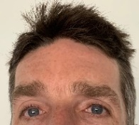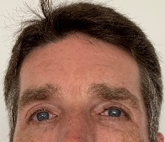

Neck:

4/27 5/24 6/6 6/10 6/13 6/20 6/29

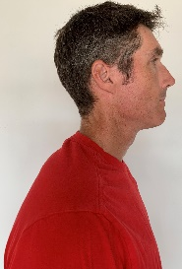

4/27/2022 6/29/2022



4/27/2022 6/10/2022 6/29/2022

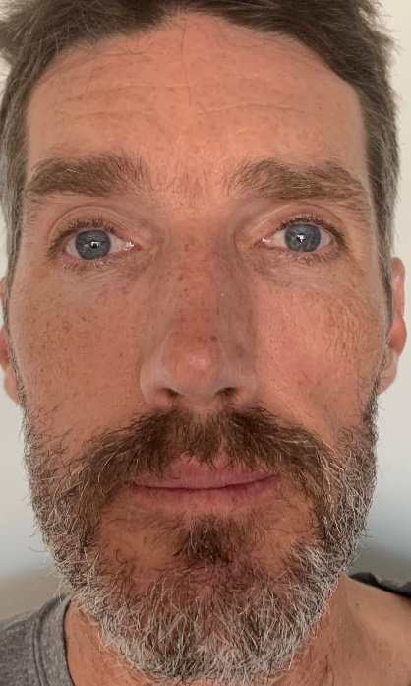

4/27/2022 6/29/2022



4/27/2022 6/10/2022 6/29/2022

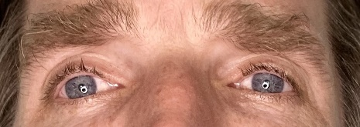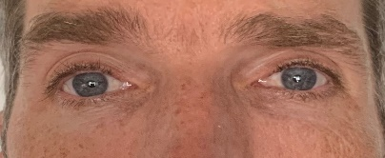



4/27/2022 6/29/2022

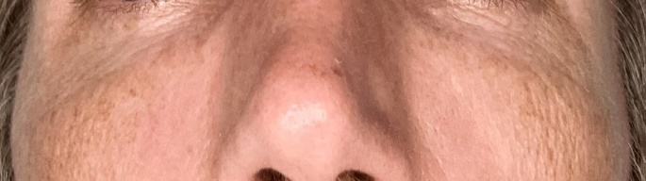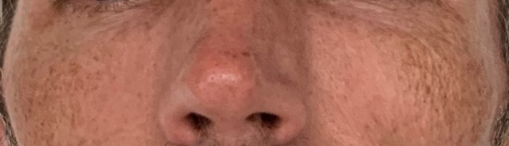



4/27/2022 6/29/2022



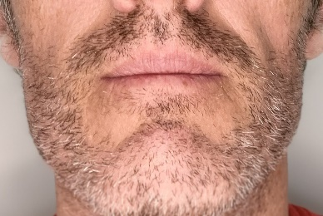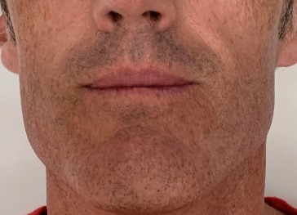



11/2008 4/27/2022 6/10/2022 6/29/2022

